

A Project

On

**BRICK-BREAKER GAME**

**Project**

**By**

**S.VIGNESH**

**Batch:** 2022 – 7671

**Center: Chennai chrompet**

Under the Guidance of,

**Mr. Chittaranjan Ghosh.**

**Technical Trainer**

**EduBridge**

(School of coding)

**Introduction:**

Our project explains about the **BRICK-BREAKER GAME USING JAVA.**

In this game, the player moves a PADDLE from side-to-side to hit a BALL. The game’s objective is to eliminate all of the BRICKS at the top of the screen by hitting them with the BALL. But, if the ball hits the bottom ENCLOSURE, the player loses and the game ends!

**Modules:-**

* **Paddle Control**
* **Bouncing ball**
* **Bricks**
* **Score counting**
* I have developed this Application in **Java8.**

**A. Paddle Control**

 The players can control the paddle movement in two different ways. It can be controlled by the keyboard as well as the mouse. The player uses the **“LEFT ARROW”** and **“RIGHTARROW”** keys to move the paddle to the left and to the right respectively.

**B. Bouncing ball**

Software will be used to assigning new locations of the ball as the ball bounce around walls (edges of the screen), bricks and paddle. When the angle of incidence changes, the angle of reflection changes too.

**C.** **Bricks**

For each brick, the software will have a status tracker. The tracker will record how many bricks in the screen.

**D. Score counting**

Software will count for the scores and calculate the bonus points gotten by how many bricks broken in a row and other effects. The score will be displayed on the up right corner of the screen.

**Software Requirements:**

* **Operating System :** Window 10.
* **Tools used :** Eclipse.
* **Languages used :** JAVA.
* **Packages used :** JAVA SWING**,** JAVA AWT.

**OUTPUT**

**Home page**

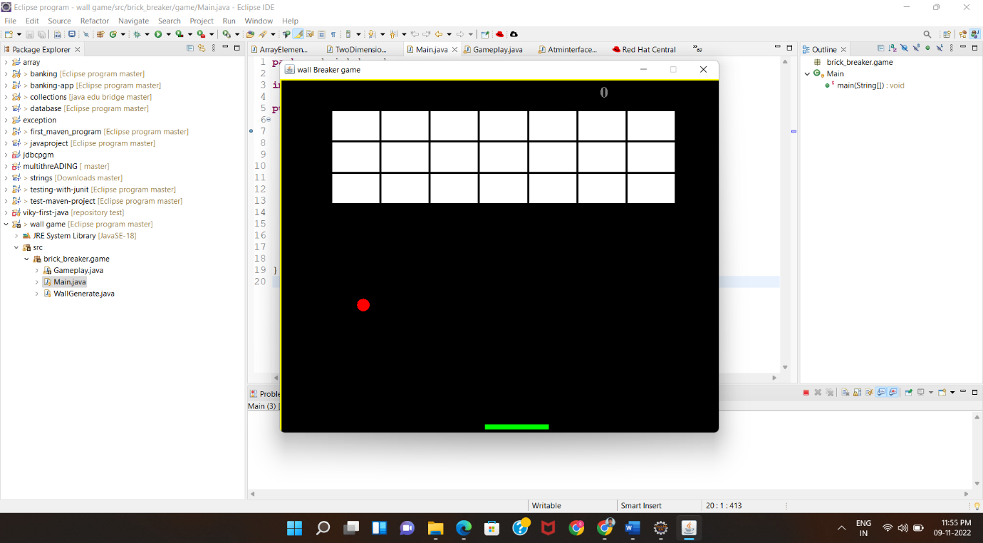

**GAME playing**

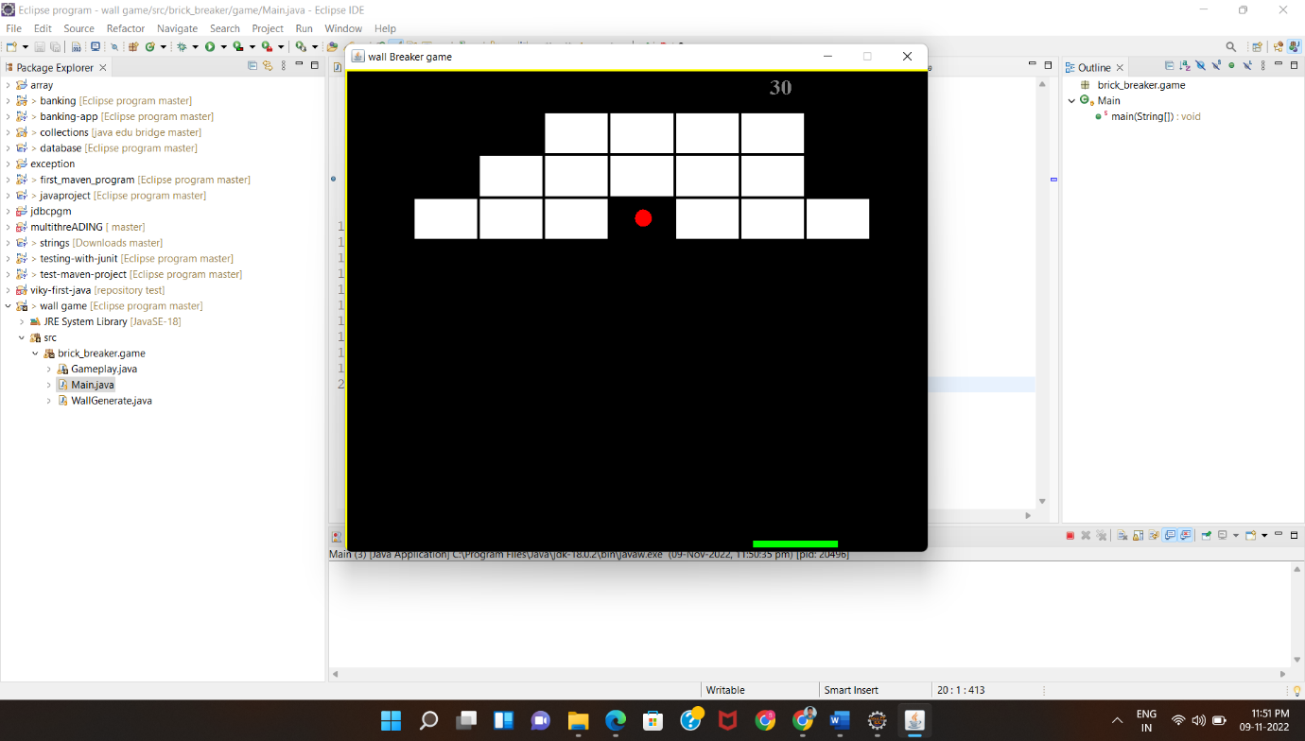

**Game over in the middle**

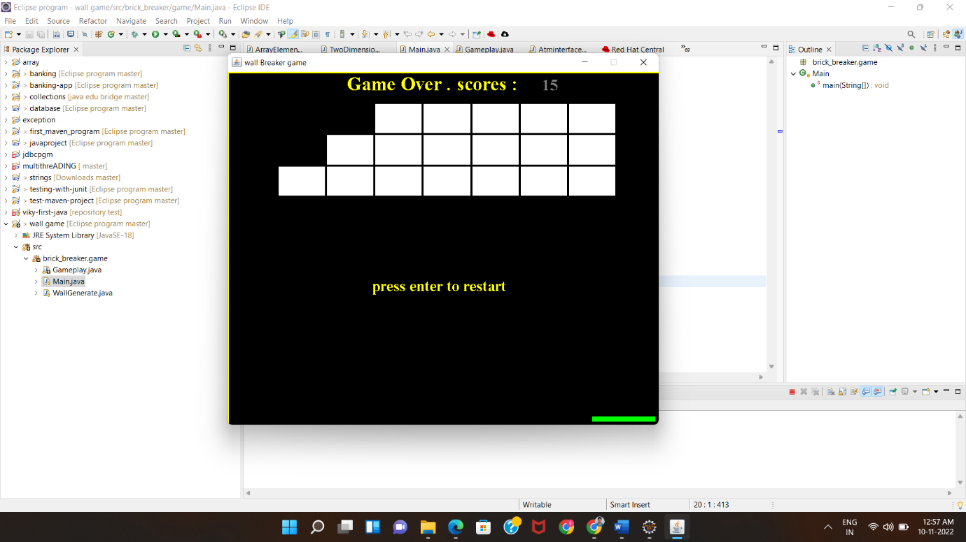

**Game over**

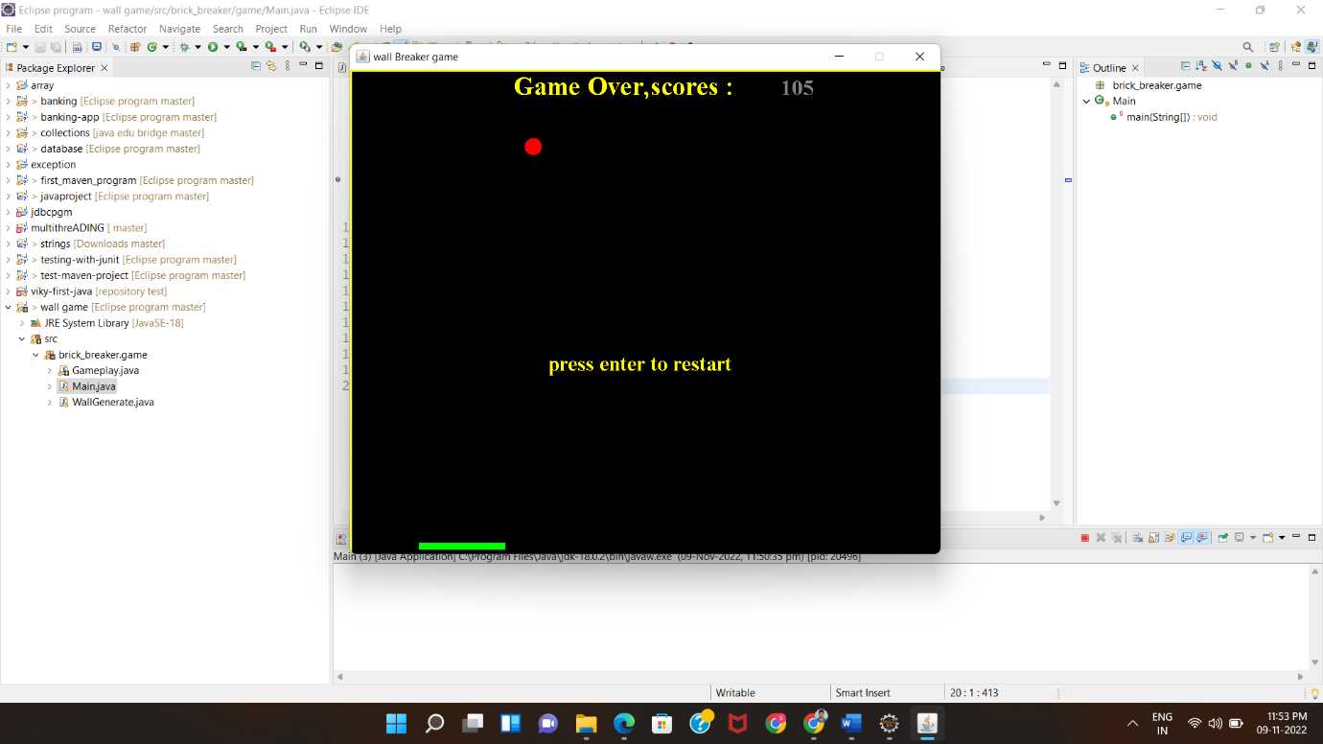

**Conclusion:**

Hopefully that gives you a good idea about what the game is about and how it has been constructed.

**Thank you**